Explanation Template PowerPoint Optimus Syria:

1. Use not the explanation slides
2. Fill in the “starting slide” the required data
3. Ein Bild, das Text, Software, Webseite, Computersymbol enthält.

   Automatisch generierte BeschreibungKlick on “Slide master”
4. Ein Bild, das Text, Screenshot, Software, Display enthält.

   Automatisch generierte BeschreibungChange the “Group members” and “Team Name” in every used layout design
5. Then close the “Master view”
6. Keep the order of the slides
7. 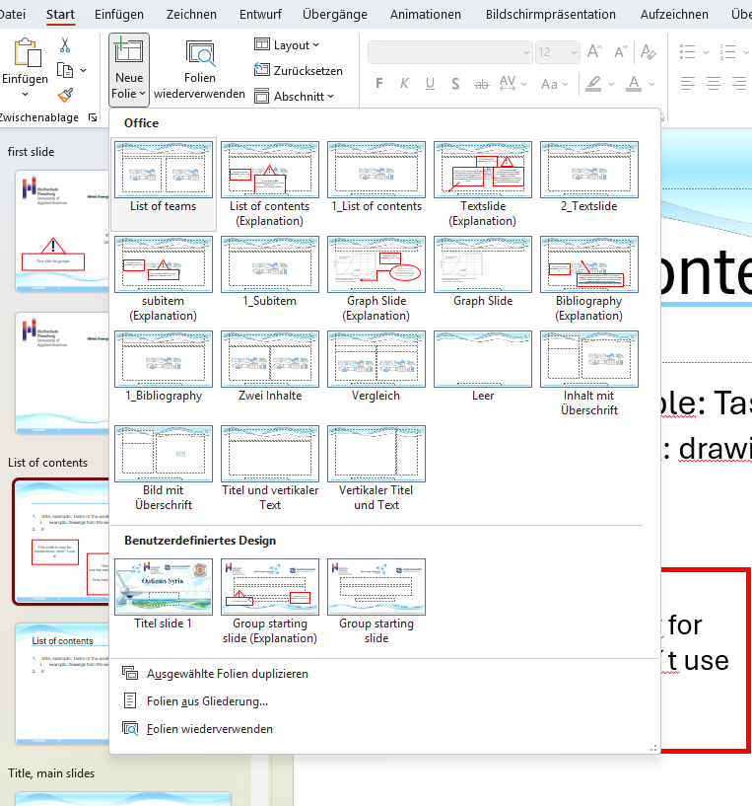Select the right layout option for your needs from the suggestions
8. Use the same style and size
9. Do not overload the slides with information, less is often more!
10. Save the sources, also for pictures and fix them on each slide on the left bottom in the brackets and then with the correct number in the bibliography slide

Implementation in your current presentation

1. Save the Template
2. Ein Bild, das Text, Software, Computersymbol, Webseite enthält.

   Automatisch generierte BeschreibungSearch and open the Template
3. Start with step 3 “Klick on “Slide master” ” above mentioned
4. Finally choose and use the correct layout

Thank you for participating, which will give us a consistent presentation image!